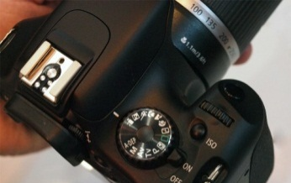
HDSLR Video Guide
Just switching your DSLR into movie mode is not enough if you really want to be a filmmaker.
Menu Settings
Movie recording size: 1920x1080 30fps – This should be your default setting
1920x1080 24fps – This is going to give you that “Film” look
1280x720 60fps– This will give you the best on action that might need to be slowed down
Movie exposure: Switch this to Manual so you can control the settings
Disable: Highlight tone priority, Peripheral Illumination correct, Auto Lighting Optimizer
Picture Style: Neutral, Image Jump: 1 image, Auto Power Off: 4 - 8 min., Color Space: Adobe RGB
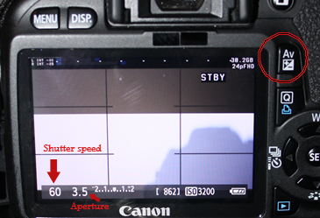
Magic Lantern
This is a firmware hack you can download to your SD card to add features to the Canon T2i/T3i.
Audio: Set Analog Gain to proper level, AGC: Off, Input Source: external if connecting a microphone
*Set Monitoring-USB and Audio Meters to ON. Then make sure to use headphones to monitor your recording!
LiveV: Both the Zebras and Focus Peaking can be helpful when you are setting up a scene, then I turn them off
*Zebras display white “zebra” stripe lines in the areas that are over exposed
*Focus Peaking displays colored areas on the parts of the image that are in sharp focus
*Histogram displays the tonal range and is a great tool for getting proper exposure
Expo: So far I love the WhiteBalance. Select it and then use the wheel to dial in your temperature.
You can also set your Shutter speed and Aperture on this menu.
Movie: Shutter Lock can be great if you don’t plan to change your shutter speed during a shoot.
Manual Settings
Focus: Always use manual focus when filming. Hit magnification button twice before focusing.
*Both the external LCD and Magic Lantern have a focus “Peaking” function that can help.
Shutter Speed: This depends on the frame rate you selected in the movie recording size.
If you selected 24fps then use 1/50th (50), 30fps then use 1/60 (60)
If you selected 60fps then choose 1/130th (130)
*Adjust with the wheel
Aperture and ISO: This will be a balancing act based on the amount of light, the desired depth of field and how graining you are willing to make your film. Aperture is also known as F-stop
Rule of Thumb: Smaller the F-stop the narrower the depth of field and the more light
Higher the ISO the more light but you also get more grain. Try to stay below 1200.
*Adjust the aperture by holding down the Av button and moving the wheel
*Adjust ISO by pressing the ISO button and then adjusting the wheel
White Balance: Set this for the type of lighting, manually or use the Magic Lantern to dial in the temperature.

